Given the HTML index.html write JavaScript function createImagesPreviewer(selector, items) in file scripts.js

* The function accepts two parameters:
  + **Selector**
    - The selector of the DOM element, where the previewer must be generated in
    - It can be any CSS3 selector (#id, .class, NODE_NAME)
  + **Items**
    - An array of objects
    - Every object in the array has two mandatory properties:
      * **title** - the title of the image
      * **url** - a path to the image (JPG/PNG)
* The execution of the createImagesPreviewer(selector, items) function should result as follows:
  + All images from the items collection must be displayed on the right
    - With their title above them
  + Above the images on the right, there must be a filter box
    - For filtering images
  + The first item from the items collection should be displayed bigger on the left
    - With its title on top
  + *Example*: [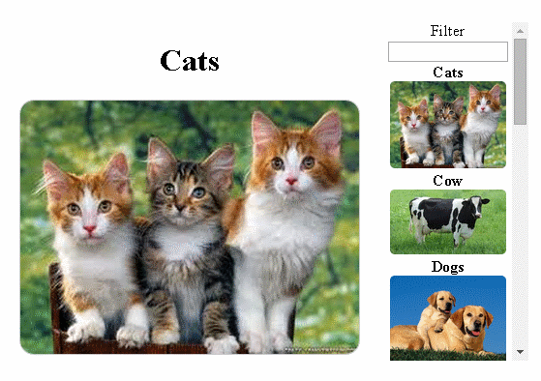](https://github.com/TelerikAcademy/JavaScript-UI-and-DOM/blob/master/Sample%20Exams/17-June-2014/task-1/result/1.%20initial.png)
* Images in the list (on the right) have some properties:
  + The title and the image must have a parent with class image-container
  + When hovered
    - They should change their **background color**
    - *Example:*  
      [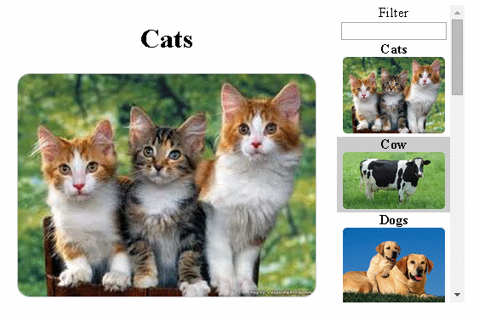](https://github.com/TelerikAcademy/JavaScript-UI-and-DOM/blob/master/Sample%20Exams/17-June-2014/task-1/result/2.%20cow-hovered.png)
  + When unhovered
    - They should return to their **default background color**
  + When clicked
    - The **bigger image and its title** (on the left) are **replaced with the clicked image on the left**
    - *Example:*  
      [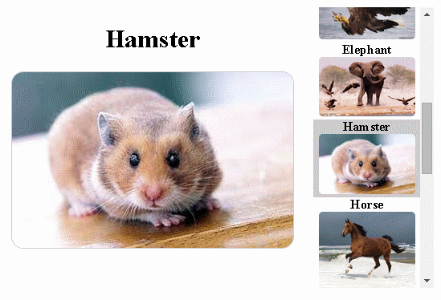](https://github.com/TelerikAcademy/JavaScript-UI-and-DOM/blob/master/Sample%20Exams/17-June-2014/task-1/result/3.%20hamster-clicked.png)
* The big image and title on the left must have a parent with class image-preview
* The filter should provide functionality for **filtering the images** on the list of images (on the right)
  + When the text in the box changes
    - The list of images should be filtered only to those that have a title containing the pattern
    - The pattern matching is case-insensitive
  + When the text in the box is empty
    - All images should be visible
  + *Example:*  
    [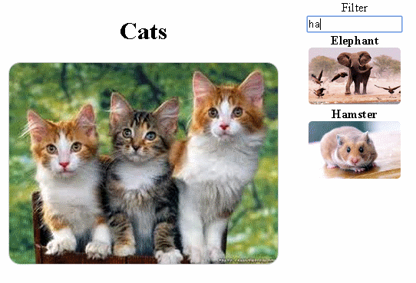](https://github.com/TelerikAcademy/JavaScript-UI-and-DOM/blob/master/Sample%20Exams/17-June-2014/task-1/result/4.%20text-in-filter.png)
* Constraints:
  + You are allowed only to edit the contents of the file "scripts.js"
  + You are NOT allowed to edit the contents of the HTML and/or the CSS files